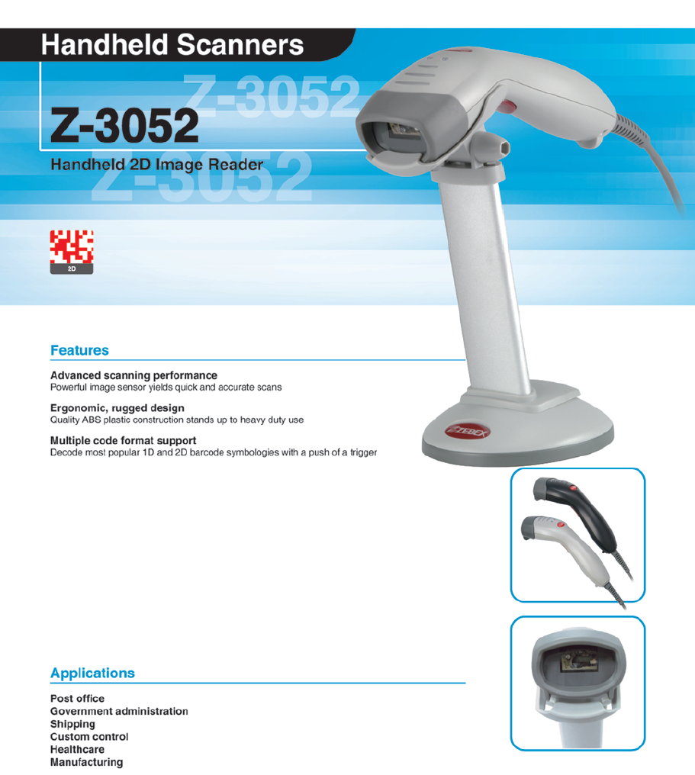



|  |  |
| --- | --- |
| **OPERATIONAL** |  |
| **http://www.zebex.com/images/TRANSPARENT.GIFAiming Element** | 650 nm visible LED |
| **http://www.zebex.com/images/TRANSPARENT.GIFIllumination Element** | http://www.zebex.com/images/TRANSPARENT.GIF635 nm visible LED |
| **http://www.zebex.com/images/TRANSPARENT.GIFOptional System** | http://www.zebex.com/images/TRANSPARENT.GIF640×480 pixels (VGA type CCD) |
| **http://www.zebex.com/images/TRANSPARENT.GIFField of View** | http://www.zebex.com/images/TRANSPARENT.GIF32.2° (horizontal); 24.5° (vertical) |
| **http://www.zebex.com/images/TRANSPARENT.GIFRotational Sensitivity** | http://www.zebex.com/images/TRANSPARENT.GIF360° (omni-directional rotational sensitivity) |
| **http://www.zebex.com/images/TRANSPARENT.GIFResolution** | http://www.zebex.com/images/TRANSPARENT.GIF6.67 mil (PDF417), 5 mil (Code 39) |
| **http://www.zebex.com/images/TRANSPARENT.GIFPrint Contrast** | http://www.zebex.com/images/TRANSPARENT.GIF30% @ UPC/EAN 100% |
| **http://www.zebex.com/images/TRANSPARENT.GIFIndicators (LED)** | http://www.zebex.com/images/TRANSPARENT.GIFTwo-color LED (green & red) |
| **http://www.zebex.com/images/TRANSPARENT.GIFProgrammable Operation** | http://www.zebex.com/images/TRANSPARENT.GIFPower mode, beeper tone, focus control, image control & trigger  http://www.zebex.com/images/TRANSPARENT.GIFmode |
| **http://www.zebex.com/images/TRANSPARENT.GIFImage File Format** | http://www.zebex.com/images/TRANSPARENT.GIFBMP (*.bmp), TIFF (*.tif), JPEG (*.jpg) |
| **http://www.zebex.com/images/TRANSPARENT.GIFSystem Interfaces** | http://www.zebex.com/images/TRANSPARENT.GIFRS-232C, USB1.1 |
|  |  |
| http://www.zebex.com/images/TRANSPARENT.GIF**PHYSICAL** | http://www.zebex.com/images/TRANSPARENT.GIF |
| **http://www.zebex.com/images/TRANSPARENT.GIFHeight** | http://www.zebex.com/images/TRANSPARENT.GIF106.76 mm |
| **http://www.zebex.com/images/TRANSPARENT.GIFDepth** | http://www.zebex.com/images/TRANSPARENT.GIF155.13 mm |
| **http://www.zebex.com/images/TRANSPARENT.GIFWidth** | http://www.zebex.com/images/TRANSPARENT.GIF58.0 mm |
| **http://www.zebex.com/images/TRANSPARENT.GIFWeight** | http://www.zebex.com/images/TRANSPARENT.GIF148 g (stand excluded) |
| **http://www.zebex.com/images/TRANSPARENT.GIFCable** | http://www.zebex.com/images/TRANSPARENT.GIFStandard 2 m straight |
|  |  |
| **http://www.zebex.com/images/TRANSPARENT.GIFPOWERhttp://www.zebex.com/images/TRANSPARENT.GIF** | **http://www.zebex.com/images/TRANSPARENT.GIF** |
| **http://www.zebex.com/images/TRANSPARENT.GIFInput Voltage** | http://www.zebex.com/images/TRANSPARENT.GIF5 VDC ±5% |
| **http://www.zebex.com/images/TRANSPARENT.GIFBattery** | http://www.zebex.com/images/TRANSPARENT.GIF1.55 watts |
| **http://www.zebex.com/images/TRANSPARENT.GIFOperating Autonomy** | http://www.zebex.com/images/TRANSPARENT.GIF350 mA |
|  |  |
| http://www.zebex.com/images/TRANSPARENT.GIF**REGULATORY** | http://www.zebex.com/images/TRANSPARENT.GIF |
| **http://www.zebex.com/images/TRANSPARENT.GIFEMC** | http://www.zebex.com/images/TRANSPARENT.GIFCE & FCC DOC compliance |
| http://www.zebex.com/images/TRANSPARENT.GIF**ENVIRONMENTAL** | http://www.zebex.com/images/TRANSPARENT.GIF |
| **http://www.zebex.com/images/TRANSPARENT.GIFOperating Temperature** | http://www.zebex.com/images/TRANSPARENT.GIF-20°C - 40°C (-4°F - 104°F) |
| **http://www.zebex.com/images/TRANSPARENT.GIFStorage Temperature** | http://www.zebex.com/images/TRANSPARENT.GIF-40°C - 70°C (-40°F - 158°F) |
| **http://www.zebex.com/images/TRANSPARENT.GIFHumidity** | http://www.zebex.com/images/TRANSPARENT.GIF5% - 95% RH (non-condensing) |
| **http://www.zebex.com/images/TRANSPARENT.GIFAmbient Light Injection** | http://www.zebex.com/images/TRANSPARENT.GIFMax. 100,000 Lux (fluorescence) |
| **http://www.zebex.com/images/TRANSPARENT.GIFShock** | http://www.zebex.com/images/TRANSPARENT.GIFDesigned to withstand 1.2 m drops |
|  |  |
| **http://www.zebex.com/images/TRANSPARENT.GIFDECODING CAPABILITY** | **http://www.zebex.com/images/TRANSPARENT.GIF** |
| **http://www.zebex.com/images/TRANSPARENT.GIF1D Barcodes** | http://www.zebex.com/images/TRANSPARENT.GIFUPC/EAN/JAN, UPC/EAN with supplementary, JAN 8 & JAN 13,  http://www.zebex.com/images/TRANSPARENT.GIFISBN/ISSN, Code 39, Code 39 with full ASCII, trioptic Code 39, http://www.zebex.com/images/TRANSPARENT.GIFCodabar (NM7), Code 128, Code 128 with full ASCII, Code 93,  http://www.zebex.com/images/TRANSPARENT.GIFInterleaved 2 of 5 (ITF), Addendum 2 of 5, MSI/Plessy, China http://www.zebex.com/images/TRANSPARENT.GIFPostal Code, UPC/EAN RSS, RSS variants |
| **http://www.zebex.com/images/TRANSPARENT.GIF2D Barcodes** | http://www.zebex.com/images/TRANSPARENT.GIFPDF 417, MicroPDF 417, MaxiCode, DataMatrix (ECC 200), QR  http://www.zebex.com/images/TRANSPARENT.GIFCode, Aztec Code, Postal Code, Composite Codes, Micro QR Code |
| **http://www.zebex.com/images/TRANSPARENT.GIFOptions** | http://www.zebex.com/images/TRANSPARENT.GIFJapanese Bookland EAN, IATA Code, Code 32, Industrial 2 of 5, http://www.zebex.com/images/TRANSPARENT.GIFStandard 2 of 5, Discrete 2 of 5, Matrix 2 of 5, Code 11 |